ABST2 -

Functionality
This program reconcile balances between the asset account determinations in AA module with the corresponding GL accounts in General Ledger.

Scenario
Following accounts to be reconciled:
- Balance sheet account APC
- Balance sheet account down payments
- Value adjustments ordinary depreciation
- Value adjustments unplanned depreciation
NOTE: This report must be run before year-end closing.
Do not make any asset postings while the report is running.

Requirements
The last depreciation run for the year should have been completely posted.

Menu Path | Accounting → Financial Accounting → Fixed Assets → Periodic Processing → Year-End Closing → ABST2 - Account Reconciliation
Transaction Code | ABST2

1. Double Click on ABST2 - Account Reconciliation

Reconcil. program FI-AA <-> G/L: List of accounts showing differences

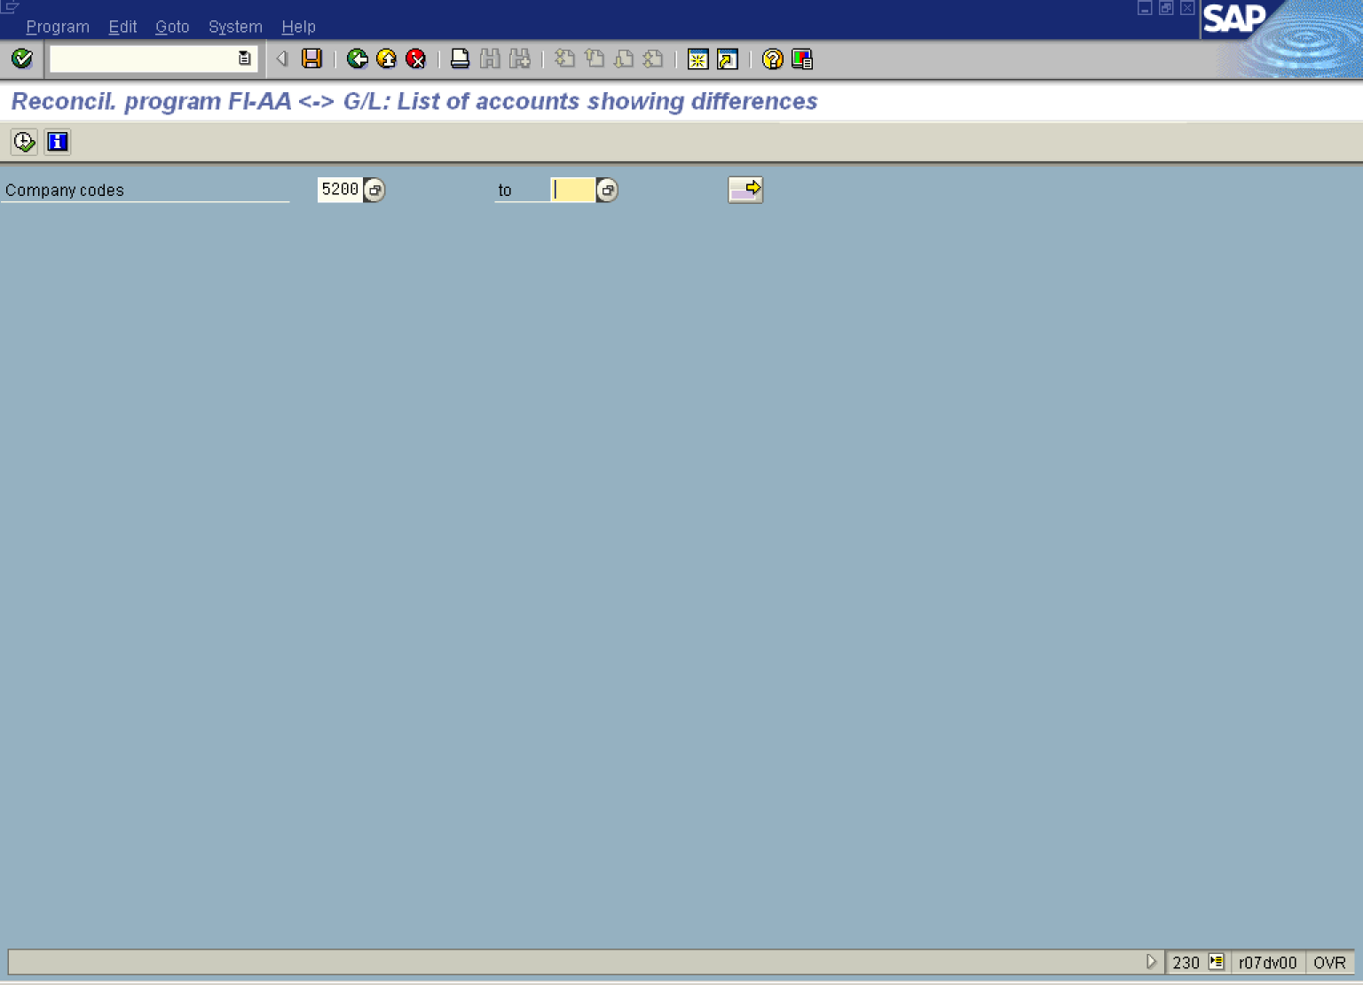

2. Update the following fields:

Field Name | Field Description | Values
Company codes | The company code is an organizational unit within financial accounting. | Example: 5200

3. Select ProgramExecute in background.

Background Print Parameters

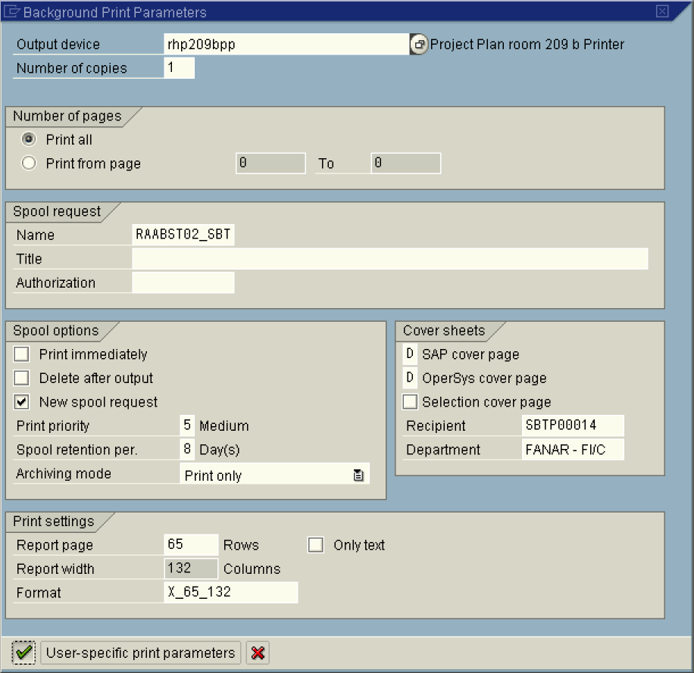

4. Click the Enter button to confirm your printer selections.

Start Time

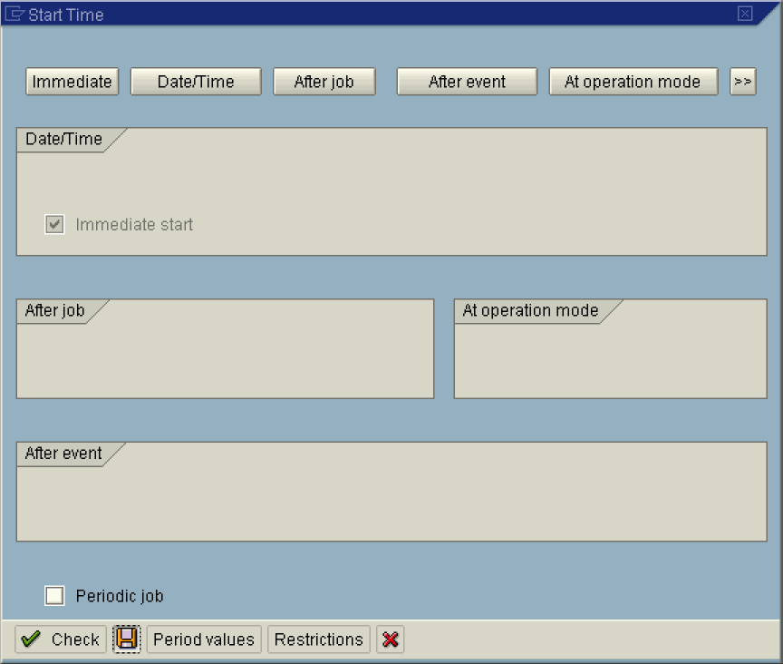

5. Click Immediate button.
Note: To run the job at a later time or after a specific event, select the relevant button. or .
6. Click the Save button.

Reconcil. program FI-AA <-> G/L: List of accounts showing differences

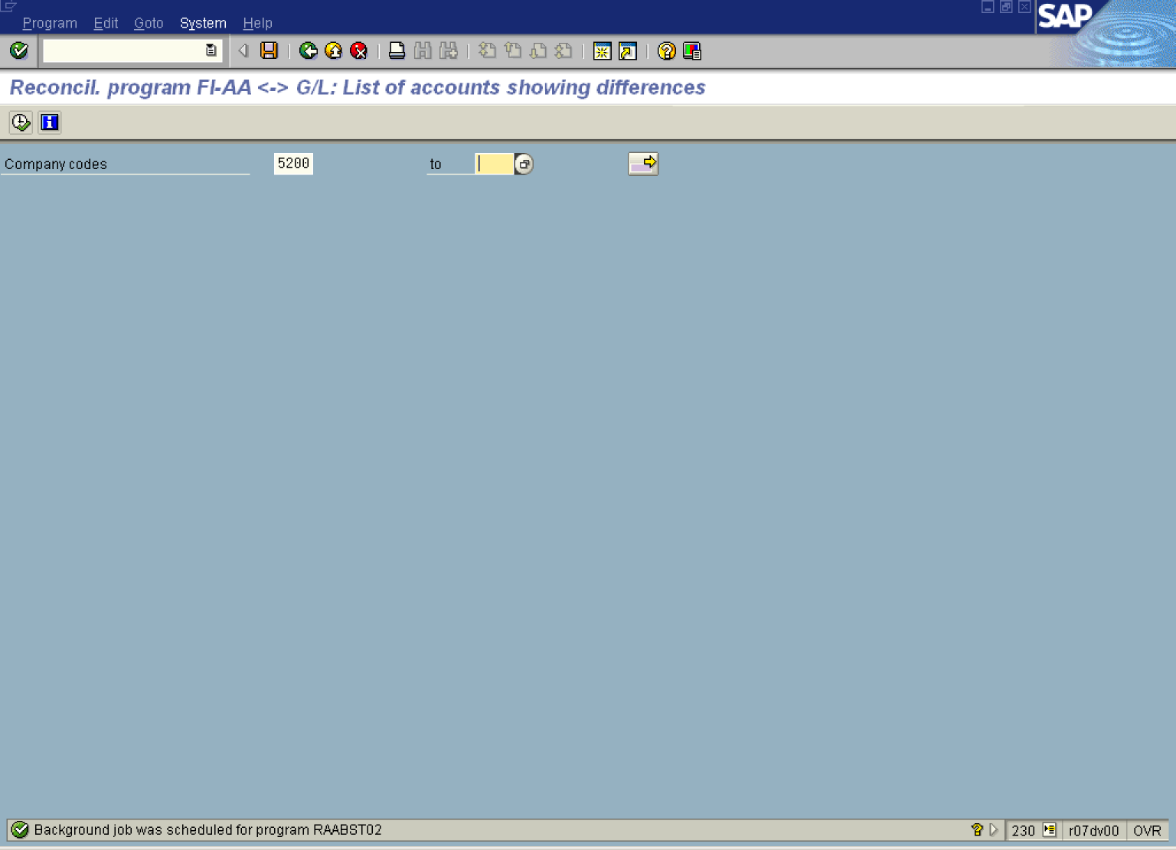

7. Select SystemServices.
Reconcil. program FI-AA <-> G/L: List of accounts showing differences

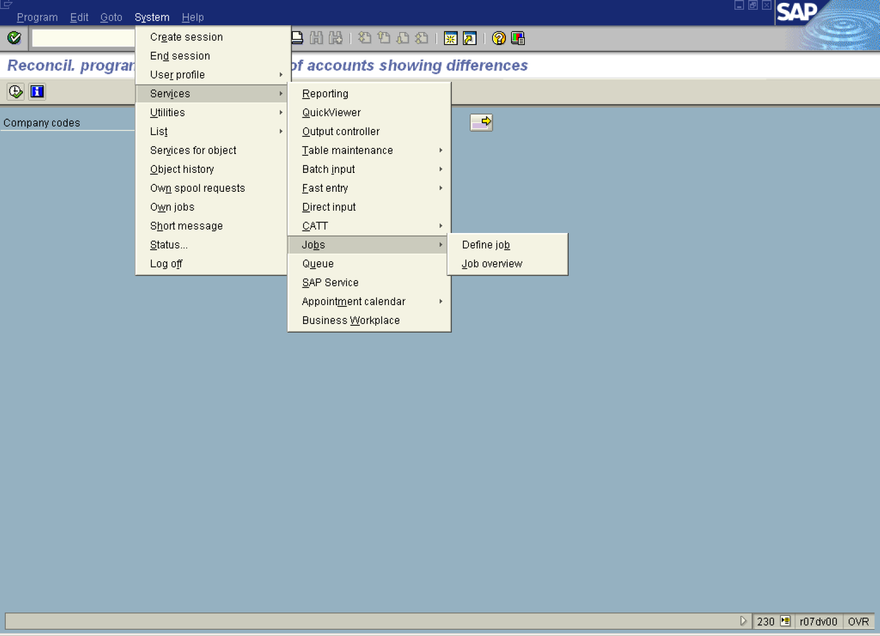

Simple Job Selection

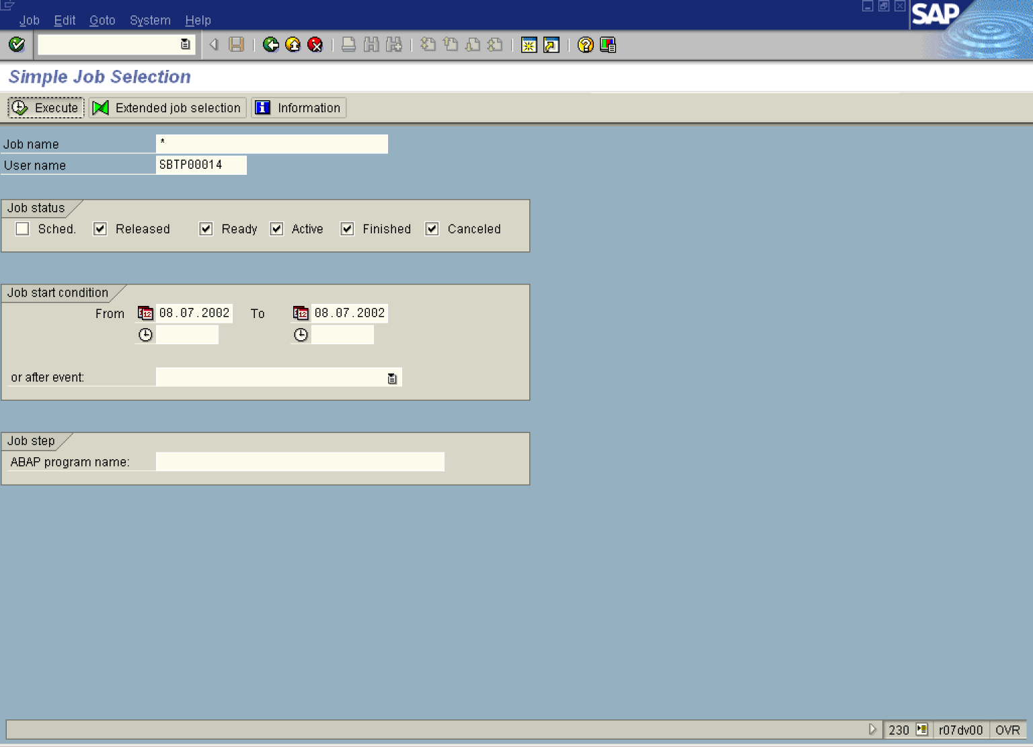

8. Click Execute Button to see a list of batch jobs.

Job Overview

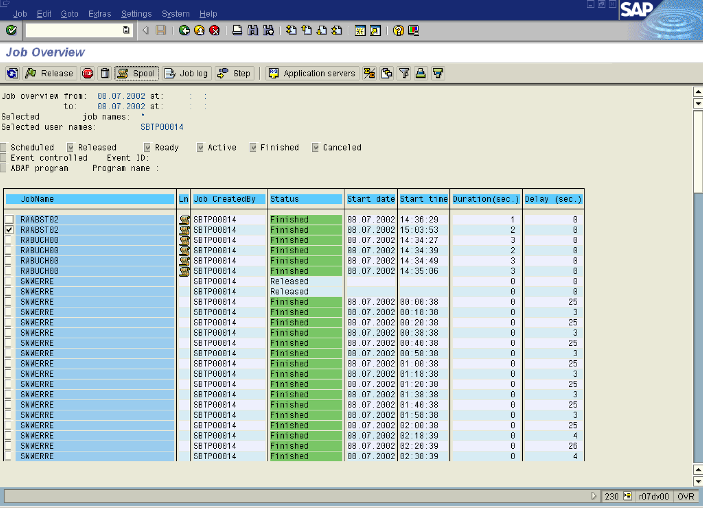

9. Click RAABST02 Button.
10. Click Spool Button .

Output Controller: List of Spool Requests

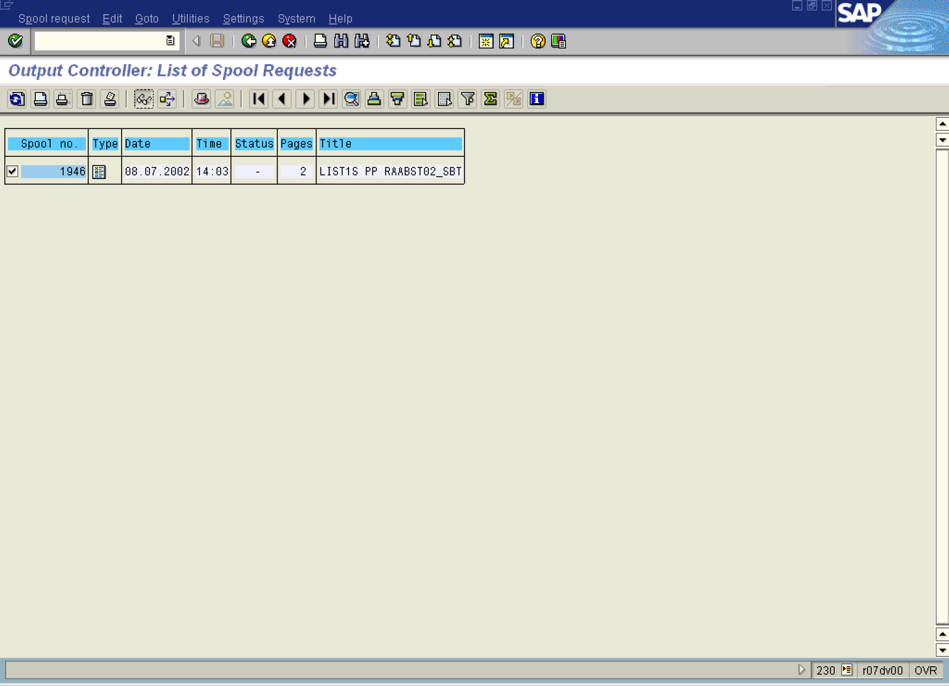

11. Click 1946 Button .
12. Click Display button.

Graphical display of spool request 1946 in system DS1

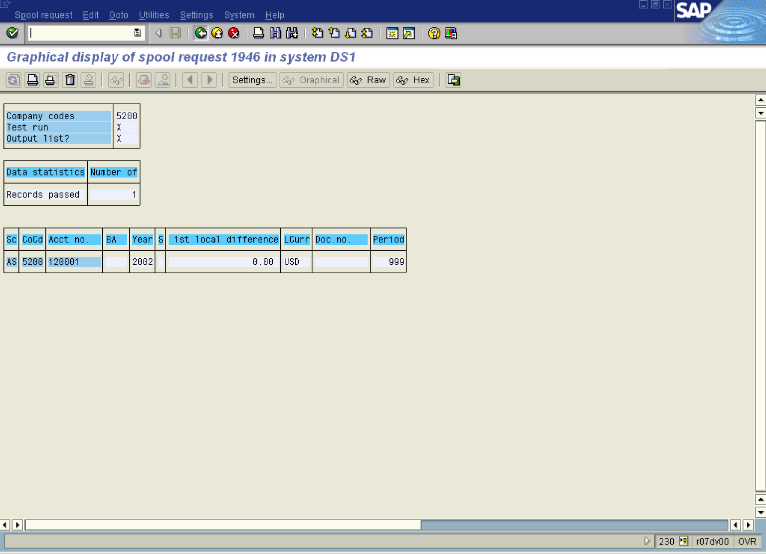

13. The system displays the status of the reconciliation process. Shown is the “zero” 1st local currency difference confirming the correctness of account balances.

